DFD-01: Classic Historic Route with Simien Mountains
Duration = 9 days/ 8 nights
Route = Historic Route with Simien Mountains National Park
Transportation: - Bus and flight
Minimum group size= 2 PAX

Month | Tour Dates | 2022  Prices | Single room  Supplement
Jan | Jan 18 - Jan 26, 2022  (Timket Festival in Addis Ababa) | USD 3,767 | USD 547
Feb | Feb 9- Feb17, 2022 | USD 3,767 | USD 547
Mar | Mar 13- Mar 21, 2022 | USD 3,767 | USD 547
Apr | Apr 12- Apr 20, 2022  (Palm Sunday festival in Axum) | USD 3,767 | USD 547
May | May 15 – May 23, 2022 | USD 3,354 | USD 487
Jul | Jul 03 – Jul 11, 2022 | USD 3,526 | USD 512
Aug | Aug07 – Aug 15, 2022 | USD 3,526 | USD 512
Sep | Sep18 - Sep26,2022  (Meskel Festival in Addis Ababa) | USD 3,526 | USD 512
Oct | Oct 09 –Oct 17, 2022 | USD 3,667 | USD 532
Nov | Nov25 – Dec 03, 2022  (St Marry Axum Zion Festival in Axum) | USD 3,667 | USD 532
Dec | Dec09 – Dec 17,2022 | USD 3,667 | USD 532

Domestic airfare
= USD 325 per person, subject to change, if a client uses ET in the international flight
=USD 631 per person, subject to change, if a client uses other carrier different from ET

Itinerary

This itinerary is designed for travelers who want to visit the northern historical attractions but don’t have much time. Visitors will cover all the important sites in the Historic circuit by flying from one site to the other. It also includes a visit to the Simien Mountains National Park, which is the only natural site of the country that is registered by UNESCO as a world Heritage.

Day 1 – Arrival + Addis
Be welcomed by your guide on arrival at Addis Ababa Bole International Airport, and transfer in to your hotel.
O/N – Jupiter International or other Similar 4* Hotel

Day 2 – Fly Addis – Bahir Dar
Fly from Addis to Bahir Dar and visit the Blue Nile Falls before lunch. In the afternoon, have a boat trip on Ethiopia’s largest water body - Lake Tana (3,600 Km Sq) to visit the island monasteries of Ura Kidane Mihret (14th Century AD) and Azwa Mariam (14th Century AD).
O/N – Avanti resort or similar
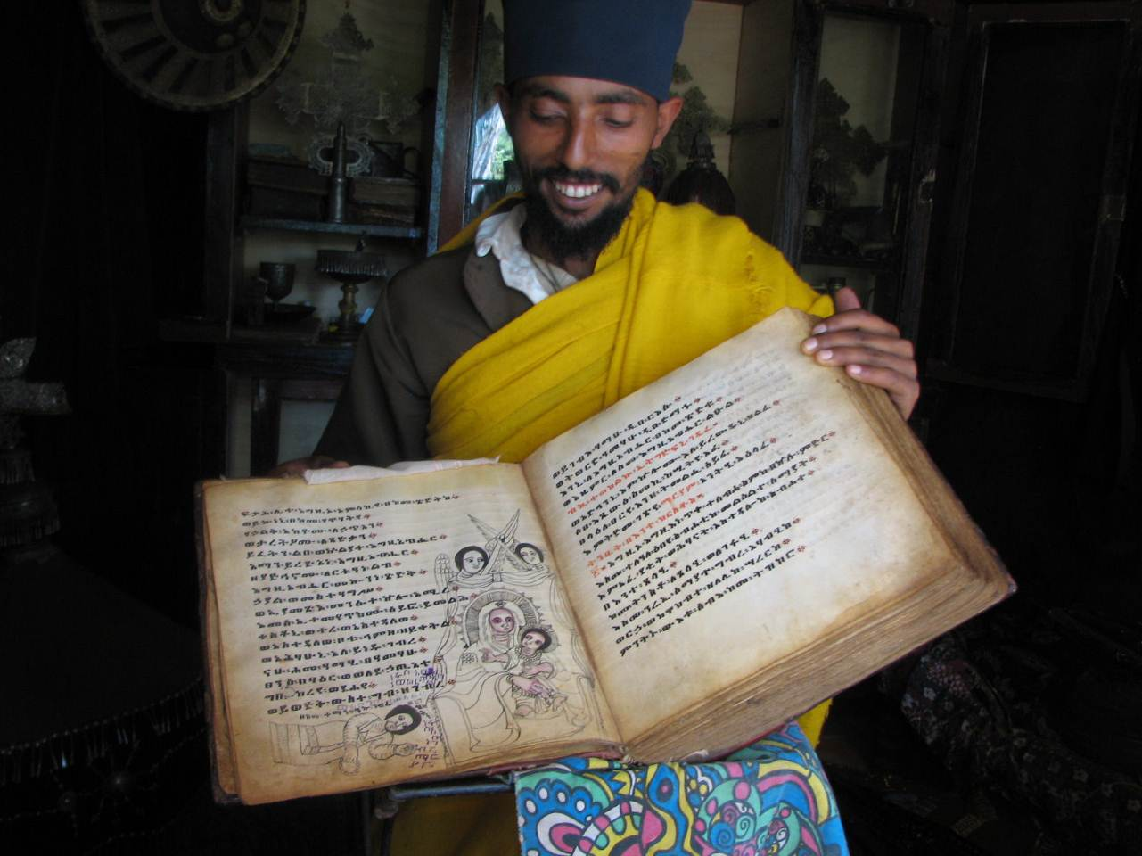

Day 3 – Drive Bahir Dar – Gondar
Drive from Bahir Dar to Gondar - the 17th century capital of Ethiopia. In the afternoon, visit the Imperial Castle Compound of Gondar (UNESCO World Heritage Site), the ‘Bath of Emperor Fasiladas’, the church of Quskuam Mariam (17th century AD), the residence of Empress Mintwab, and the church of Debre Birhan Sillassie which is famous for its wall and ceiling paintings.
O/N – Goha Hotel or similar

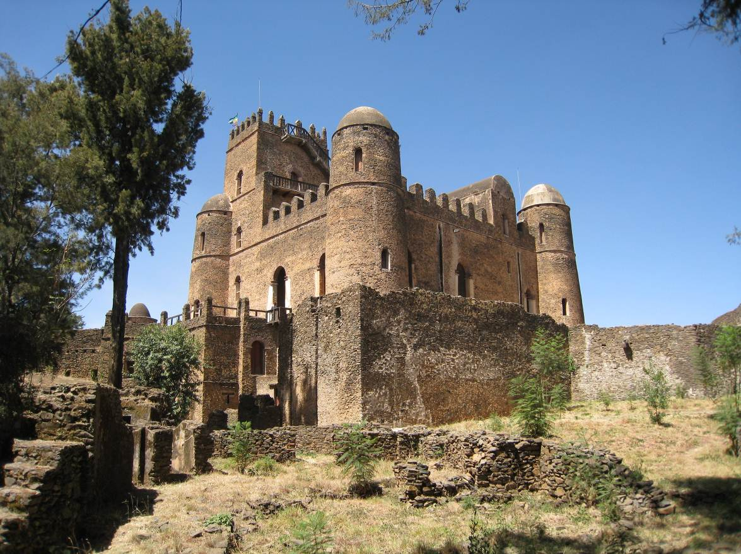

Day 4 – Drive Gondar – Simien Mountains National Park
Drive from Gondar to Debark (the headquarter of the Simien Mountain National Park), and proceed 36 km farther to the Simien Mountains (UNESCO World Heritage Site) to visit the endemic mammal of Ethiopia - the Gelada Baboon, and the breathtaking scenery of the Simien Mountains.
O/N – Simien Lodge

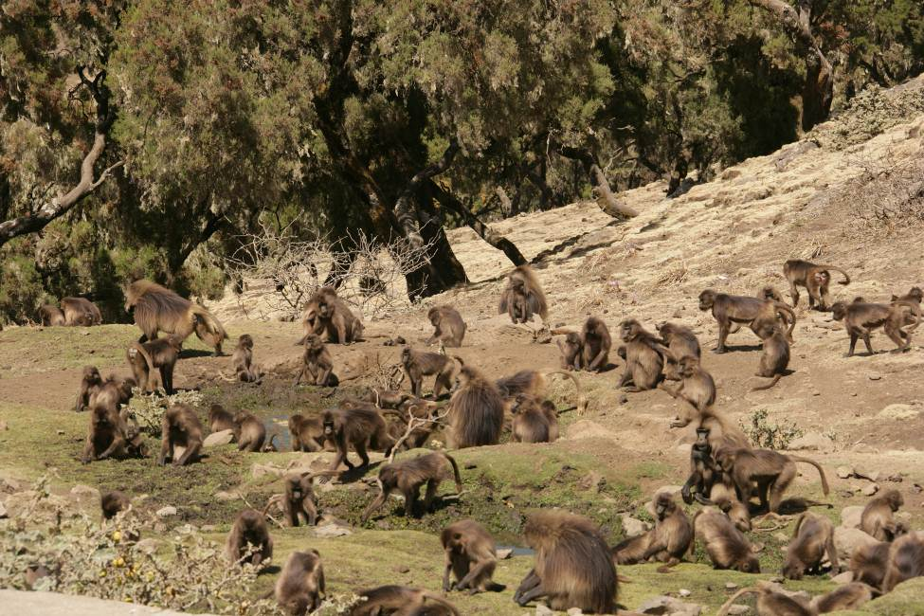

Day 5 - Simien Mountains National Park – Axum

Drive to Axum - the earliest Capital of Ethiopia, crossing the Tekezze Gorge.

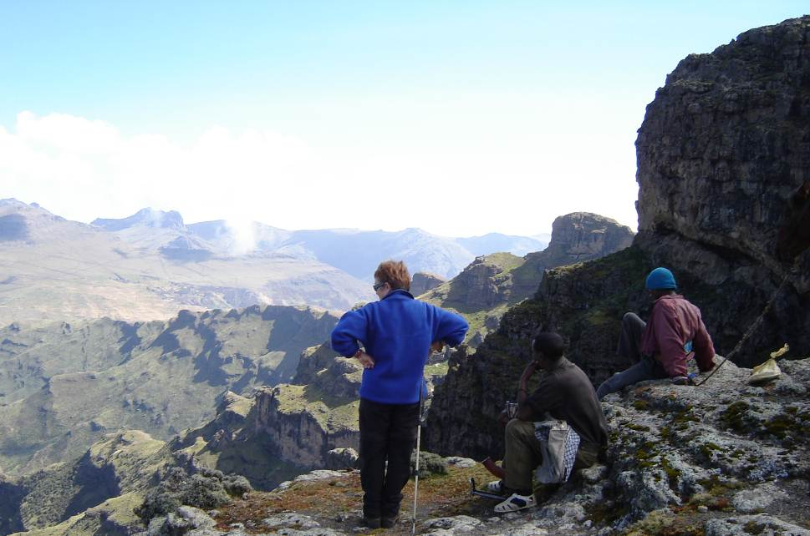

O/N – Sabean Hotel or similar

Day 6 – Axum
Today, we will make full day sightseeing tour of Axum. We get our first glimpse of the history of this area with a city tour that includes the Archaeological museum of Axum and the Cathedral of St. Mary of Zion. The original church was built by Emperor Fasiladas, founder of Gonder, in 1665. It’s thought that this church is built on the original foundations of a temple build by King Ezana or King Kaleb in the 4th or 6th centuries, making this the oldest Christian site in Africa. Keep your eye out for the guarded chapel, which is said to be the home of the Ark of the Covenant. The modern St. Mary’s of Zion cathedral dates from the 1960s when Emperor Haile Selassie had it build. The architectural style is painfully out of place in the ancient city, but the contrast between the buildings on the site is fascinating. We also spend time exploring the on-site museum under the church, which houses many of Ethiopia’s priceless relics (the museum was recently opened to both women and men, photography is not allowed).

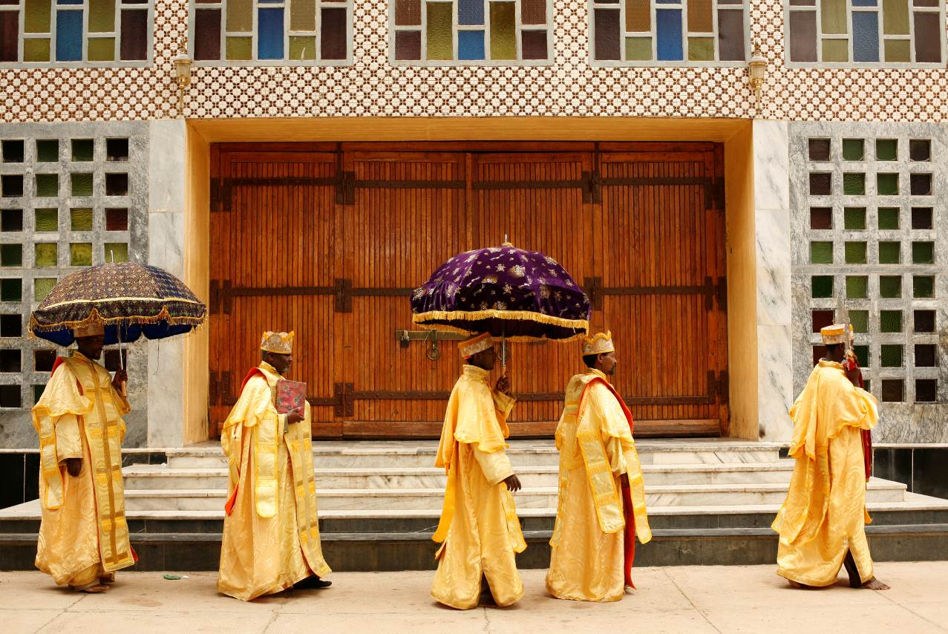
In the afternoon, visit the famous ‘Stele field’ (4th Century AD and UNESCO World Heritage Site, the ruin palace and tomb of King Kaleb and King Gebre Meskel (5th and 6th Century AD) and the residence of the legendary Queen of Sheba (9th century BC). The North Stelae Park contains over 120 stelae, some are upright, some are buried and others have been removed. The Rome Stelae, the tallest at 25m high, was shipped to Italy in 1937 under orders from Mussolini, but has since been returned and re-erected.

O/N – Sabean Hotel or similar

Day 7 – Fly Axum – Lalibela
In the morning, fly to Lalibela – home of the 12th century AD rock hewn churches of King Lalibela. And in the afternoon, visit the first group of churches of King Lalibela (UNESCO World Heritage Site).
O/N – Maribela Hotel or similar

Day 8 – Lalibela
In the morning, mule back ride to the hill top semi monolithic church of Asheton Mariam (13th century AD). Getting to the top of the hill rewards with great and unforgettable scenery of the area. In the afternoon, visit the remaining second and the third group of the churches of Lalibela.
O/N – Maribela Hotel or similar

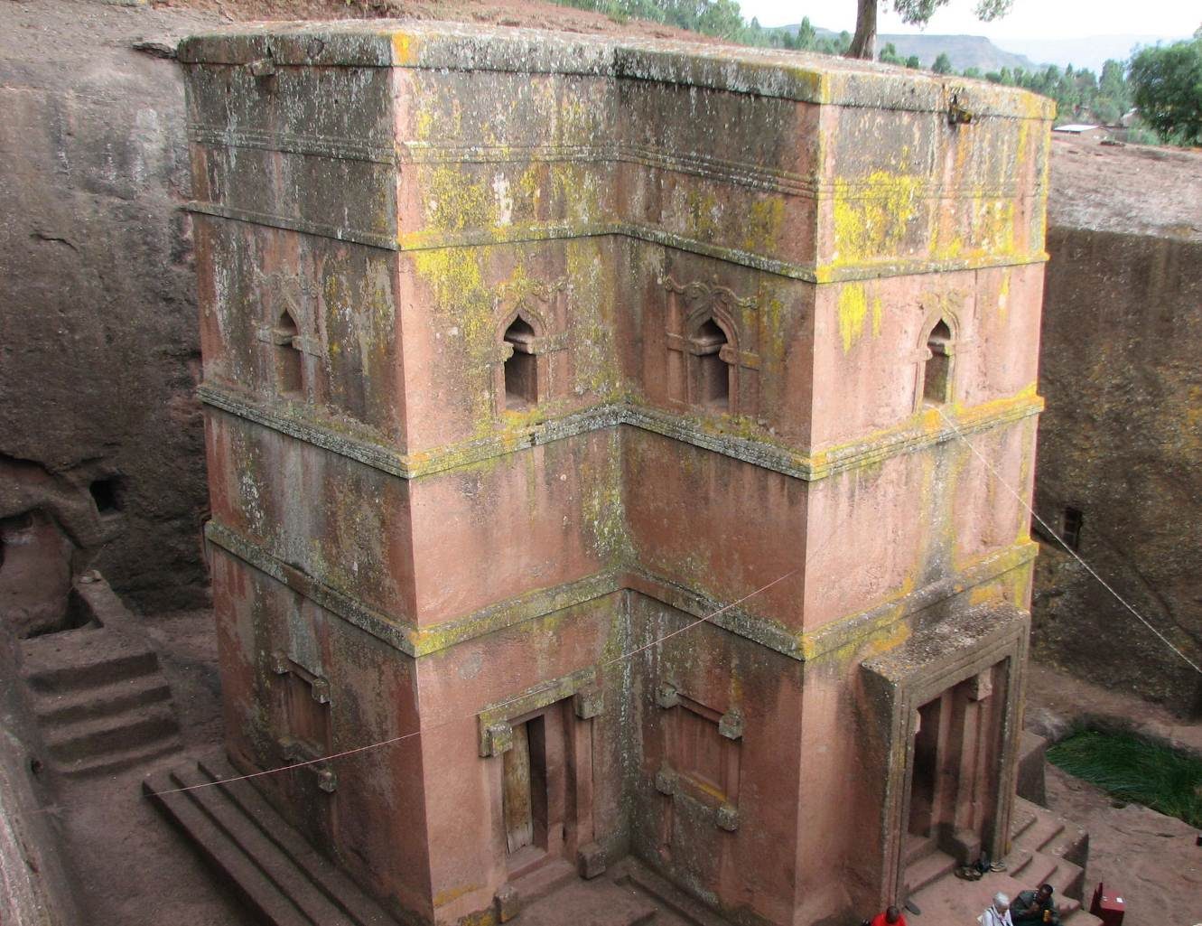

Day 9 – Lalibela – Addis + departure
Fly back to Addis and have a half-day city tour of Addis that includes visiting the National Archeological Museum of Addis Ababa, Merkato - the largest open-air market in Africa, and driving to Mt. Entoto (3,200 meters) to have a panoramic view of the capital.
In the evening, you will be invited a fare well dinner party at one of the best traditional restaurants of Addis to see the folkloric dances of the Ethiopian people and to taste the variety of meals of the Ethiopian people.
Departure

Price inclusive of: -
- Accommodation on a twin room sharing basis
- All meals out of Addis, and only breakfast in Addis
- All entrance fees
- Transfers
- Mule hire
- Boat rent at Lake Tana
- All ground transportations with fuel, and insurance
- Professional English speaking guide
- Portage fees
- All local guides
- Scouts
- Government tax

Price exclusive of:-
- International airfare
- Lunch and dinner in Addis
- Any alcoholic drinks
- Personal expense like souvenirs, laundry, etc
- Tips
- Any expense which is not stated in the ‘Included List’ above

